**Digital Signal Processing Lab**

**EEL-325**

Lab Journal: 01



Name: M.OMAR

Class: BCE-6

Enrollment No: 01-132182-024

**Lab # 01**

**Two Dimensional Graphs and Matrix Implementation**

**Objective:**

* To study about MATLAB software.
* Two-dimensional plotting using MATLAB Software.
* Matrix Implementationusing MATLAB Software

**Procedure:**

* Open MATLAB Software.
* Make a new script and name it on the name of your lab.
* Make your tasks in the same folder and keep them at the same directory.
* Make functions and name them same as your script name.
* Make sure that the main function and the other functions are in the same directory.
* Run the given code and see the output.

**Problem No. 01:**

**Task 1: Draw graphs of the functions:**

**Y1 = Cos(πt); Y2 = Sin(2πt); Z = Y1 + Y2 where 0< t >5**

**a. Y1 = Cos(πt);** MATLAB Code:

t = 0:0.001:5; y1 = cos(pi*t); plot(t,y1) xlabel('time','fontsize',14); ylabel('amplitude','fontsize',14);

Output:

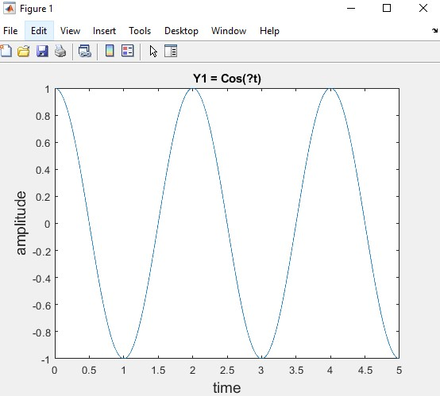

**b. Y2 = Sin(2πt);** MATLAB Code:

t = 0:0.001:5;

y2 = sin(2*pi*t); plot(t,y2) xlabel('time','fontsize',14); ylabel('amplitude','fontsize',14);

Output:

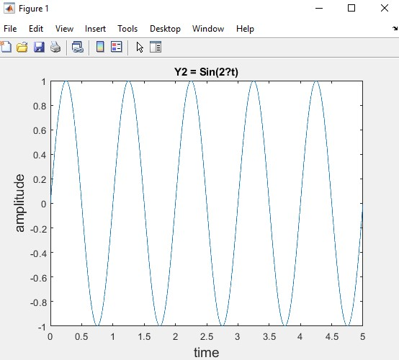

**c. Z = Y1 + Y2** MATLAB Code:

t = 0:0.001:5; y2 = sin(2*pi*t); y1 = cos(pi*t); Z = y1 + y2; plot(t,Z) title('Z = y1 + y2'); xlabel('time','fontsize',14); ylabel('amplitude','fontsize',14);

Output:

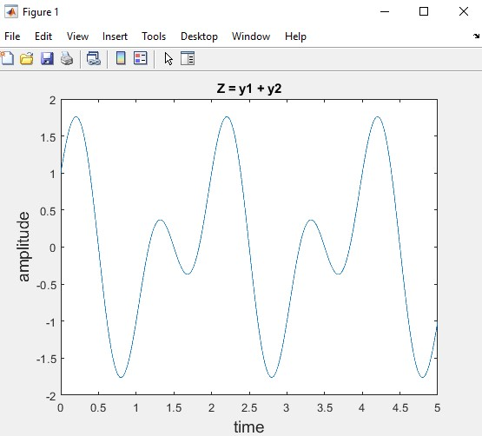

**Task 2: Draw graph of the given function:**

𝒀𝒀 = 𝒆𝒆𝒏𝒏𝒏𝒏 **on interval -1 ≤ x ≤ 1 for n=1, 2,. . 4. Use Sub-plots.**

MATLAB Code:

x = -1:0.001:1;

n = 1; y1 = exp(n*x); subplot(2,2,1); plot(x,y1); title('y=e^1^x'); xlabel('time','fontsize',14); ylabel('amplitude','fontsize',14); grid on

n = 2; y2 = exp(n*x); subplot(2,2,2); plot(x,y2); title('y=e^2^x'); xlabel('time','fontsize',14); ylabel('amplitude','fontsize',14); grid on

n = 3; y3 = exp(n*x); subplot(2,2,3); plot(x,y3); title('y=e^3^x'); xlabel('time','fontsize',14); ylabel('amplitude','fontsize',14); grid on

n = 4; y4 = exp(n*x); subplot(2,2,4); plot(x,y4); title('y=e^4^x'); xlabel('time','fontsize',14); ylabel('amplitude','fontsize',14); grid on

Output:

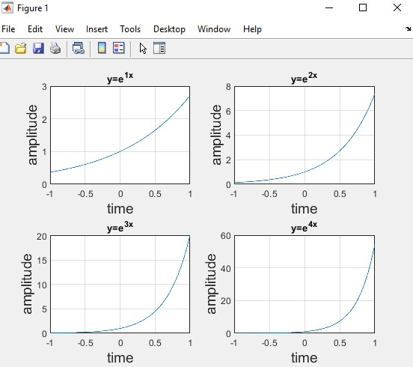

**Task 3: Draw graph of the given function:**

**Y=t.Sin (3t); Where t is an input by the user to the function.**

MATLAB Code:

x = -1:0.001:1; t = input('Enter the value of t = '); y = t*sin(3*t); plot(x,y) title('Y = tSin(3t)'); xlabel('time','fontsize',14); ylabel('amplitude','fontsize',14); grid on

Output:

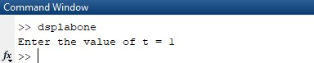

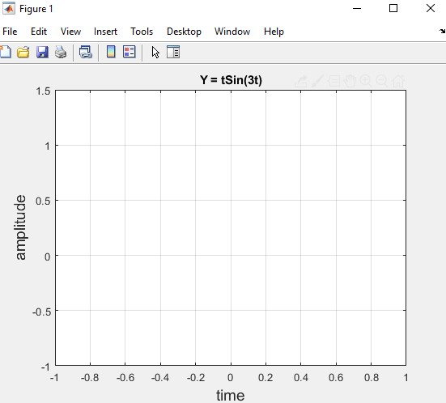

**Problem No. 02:**

**Task 1: Write a function row operation (A), Where A is 3x3 matrix [1,2,3;4,5,6;7,8,9].**

**The function should perform following tasks**

* **Add Row1 and Row3**
* **Subtract Row3 and Row1**
* **Multiply Row1 and Ror2**
* **Divide Row2 and Row1**

MATLAB Code:

A = [1,2,3; 4,5,6; 7,8,9];

row1 = A(1,:); row2 = A(2,:); row3 = A(3,:);

add = row1+row3 subtract = row3-row1 multiply = row1.*row2 divide = row2./row1

Output:

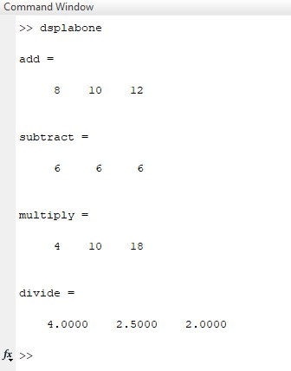

**Conclusion:**

In this lab we learned about plot,subplot commands. How to take input from user.and how to perform operations on a matrix.